Title of the Program: Orientation Talk on Gender Sensitization
Date & Time : 19-08-2025 & 2.30 p.m.
Venue : Seminar Hall Organized by :Women Development Committee Resource Person : Dr T.Madhavi, Chairperson, Women Development Committee.
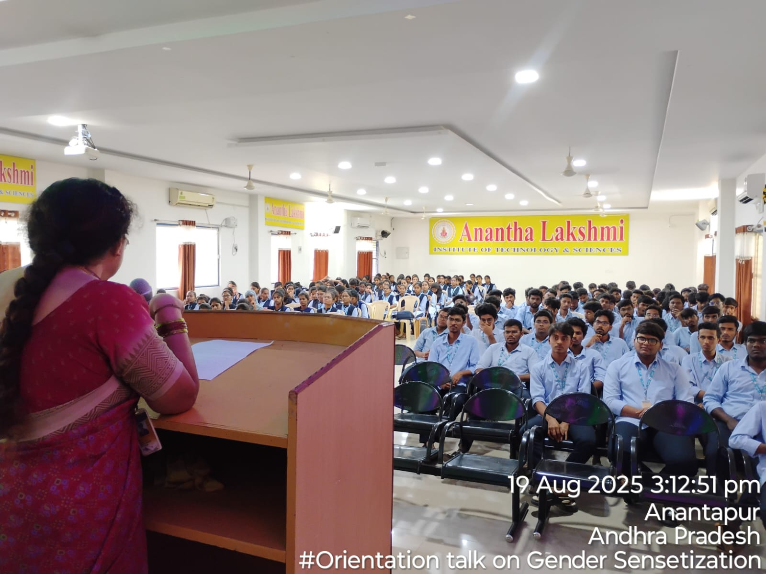Figure-1: Dr T.Madhavi, the Chairperson of Women Development Committee, ALTS addressing the gathering.
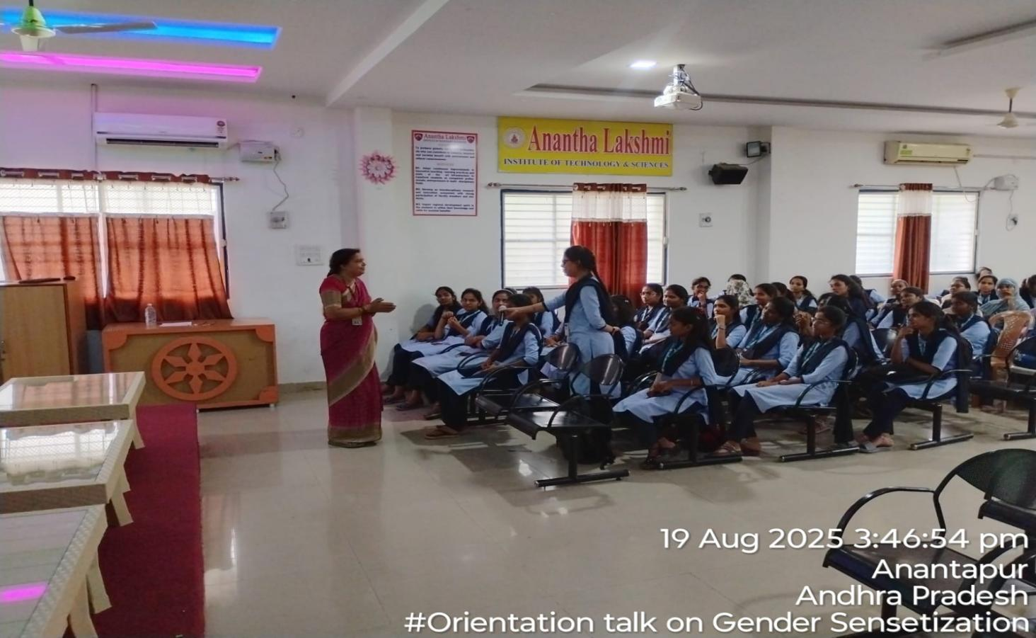
Figure-2 : The Resource Person Dr T.Madhavi interacting with the students.
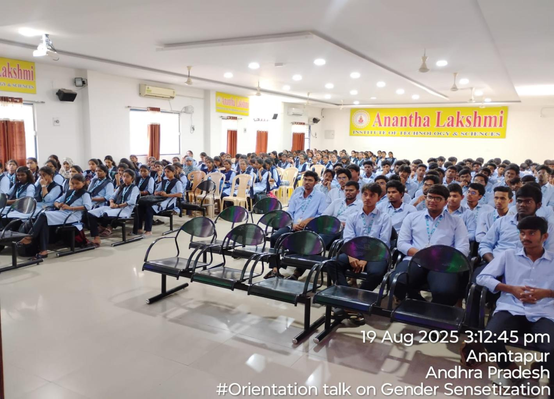
Figure-3: The participation of the students.

